Step 1 : Login Page (Enter official email id and Name)

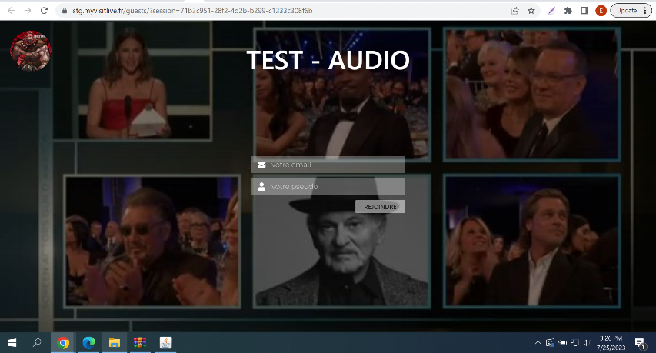

Step 2: Select 1st option to join from laptop/desktop -

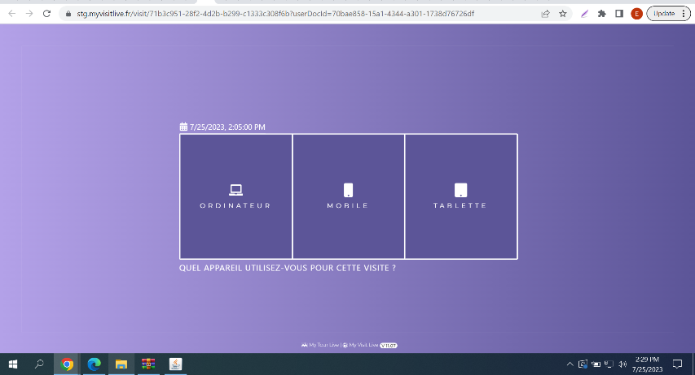

Step 3 : Click “Entrer Dans La Visite” button to enter the call

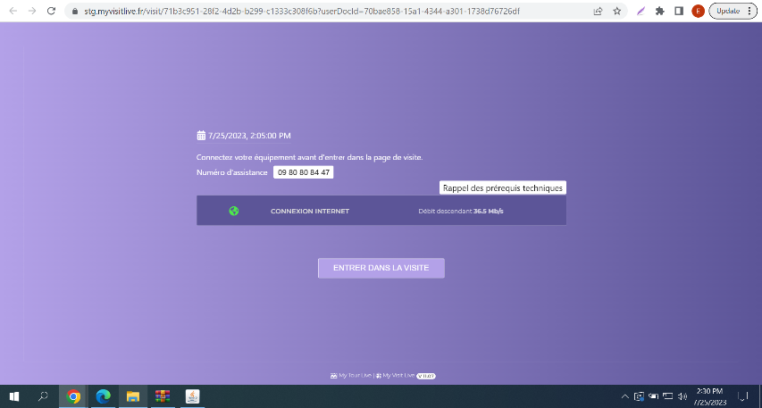

Step 4 : Call room, where check audio, video and chat feature.

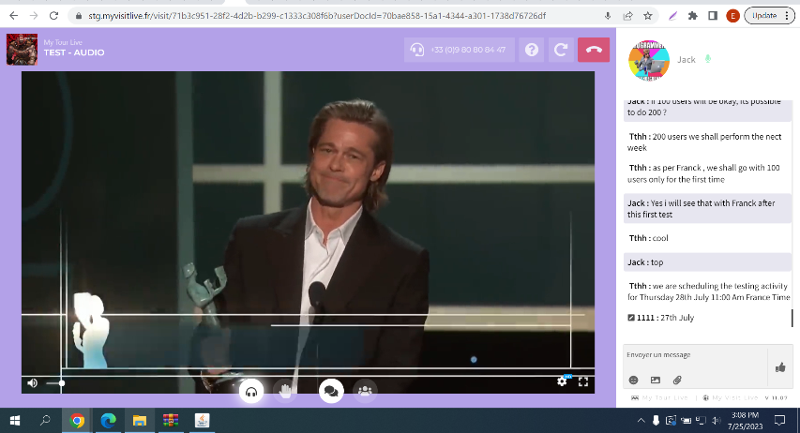

Step 5 : Star rating screen after ending call, click “Valider” to submit

